# Yes, mistakes were made, but we must never stop being proud of the Empire

**Yes, mistakes were made, but we must never stop being proud of the Empire**

**By Lawrence James**

**18 April 2012, MailOnline**

The Empire is suffering yet another posthumous assault. Its assailants have some new ammunition, dredged from documents just released by the National Archives, which detail the nasty expedients employed occasionally when British power was challenged.

The enemies of the Empire imagine they have a treasure chest brim-full of hard evidence that will prove it was irredeemably wicked.

These files have already prompted predictable hand-wringing and breast-beating at the Guardian (where they made front page news) and the BBC (on which they featured heavily on Radio 4’s morning news) — two institutions where the prevailing wisdom is that Britain should be ashamed of its imperial past.

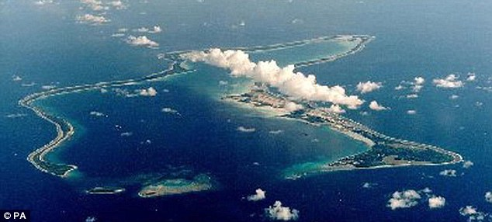

*Disgraceful: Recently-unearthed papers show how the British government deported inhabitants of Diego Garcia (pictured) to make way for a US air base*

The tribunes of political correctness will soon be clamouring for apologies to the descendants of our  former subjects and wads  of compensatory cash to  their governments.

***Decency***

I will not argue that there is no cause for disquiet in the revelations. The chicanery employed by the British authorities to evict the 1,500 islanders of Diego Garcia from their home in the Indian Ocean to make way for a U.S. military base in 1970 was disgraceful.

Edward Heath’s government was furtive on the issue, and one Foreign Office mandarin dismissed the Diego Garcians as ‘a few Tarzans and Man Fridays’ — a reminder that even in the final days of the Empire its servants were capable of breathtaking arrogance.

The 50-year lease to the Americans is due to expire in 2016, so there will be an opportunity to treat the islanders and their descendants with that decency which so many of the Empire’s subjects expected from the British.

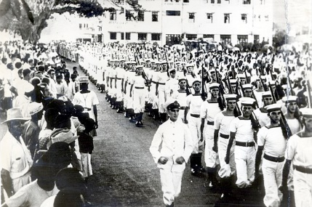

*Most of the revelations concern the Mau Mau rising in Kenya from 1952 to 1956. Here British troops march through Mombassa to crush the rising*

Yet the rest of the revelations confirm only what is already well known. The bulk of them concern operations against the Mau Mau insurgency in Kenya between 1952 and 1956.

This was a bush war by the British against a secret society whose aim was land redistribution and which attracted a following among members of the Kikuyu tribe.

The upshot was a peasant insurrection and a civil war among the Kikuyu, many of whom rejected the mumbo jumbo of the Mau Mau and fought alongside the British.

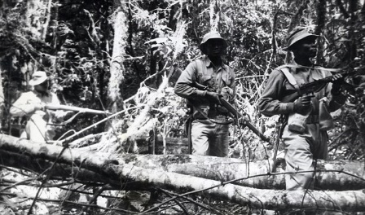

*Uncertain allegiances: Many Kikuyu actually fought alongside the British*

Mau Mau partisans resorted to mass murder and mutilation to intimidate the loyalists.

A wave of atrocities terrified the colonial government and the white settlers, who panicked and launched a counter terror. Its grimmer features have  been known about for at least 30 years.

The Colonial Office files in the National Archives describe the torture and shooting of captured suspects. There were questions in the Commons, and the local commander General Erskine had to order British troops to stop ‘beating up’ suspects, which, he rightly argued, made the task of extracting information more difficult.

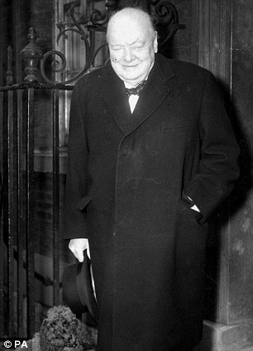

*Horrified: Winston Churchill feared that rogue officers in Kenya were giving the Empire a bad name*

Winston Churchill, the then prime minister, was horrified by such reports. In December 1954, and on the verge of tears, he told the Kenyan politician Sir Michael Blundell that the outrages were blackening Britain’s good name and were alien to British ‘traditions’ and ‘democracy’.

He admired the ‘fibre and ability and steel’ of the Mau Mau warriors, he said, and sincerely hoped that, through ‘flexibility’ and ‘magnanimity’, they could be persuaded to negotiate.

This did not happen. Yet, as his remarks suggest, Churchill’s faith in the Empire as a moral force for good remained.

In fact, the situation in British Africa was fraught and complicated. It should be remembered that in 1954, Britain was enmeshed in the political complexities of the Cold War.

The U.S. insisted on the rapid granting of independence to its colonies to improve the image of the ‘Free World’ and, simultaneously, expected Britain to deal firmly with any uprisings that might be exploited by the Russians.

Intelligence investigations found no link between the Mau Mau and communism, though there was disturbing evidence that nationalists elsewhere in British Africa were contemplating Mau Mau-style rebellions.

This background, combined with the visceral fear the Mau Mau generated in Kenya, explains the desperate measures adopted by the authorities. So the documents about to be made public — which the Left has seized on with such vigour — will not add anything significant to our understanding of the problems faced by the authorities in Nairobi.

Rather, they will be a distasteful catalogue of how frightened civil servants, police and intelligence officers reacted in an exceptional crisis.

When the going got bad, the British played rough. The evidence for this can be found in official files on 20th-century conflicts on the North- West Frontier of India, Iraq  and Palestine.

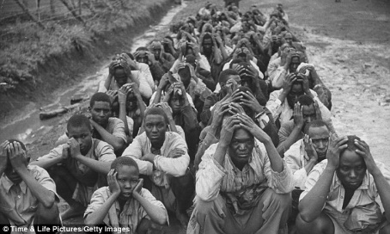

*Backlash: The atrocities of the Mau Mau rebels caused a crackdown that was sometimes brutal*

All this confirms what has been known since the earliest days of the Empire: exasperated and frightened generals and pre-consuls did resort to harsh measures in campaigns of conquest and pacification.

Moreover, the servants and guardians of the Empire, while overwhelmingly dedicated, loyal and disciplined, included a sprinkling of misfits, incompetents and bullies. This may be regrettable, but it is hardly surprising.

I believe that the faults of the Empire are more than outweighed by the benefits it extended to its millions of subjects. This was the view of Churchill and it explains his anguish when he confronted the reports from Kenya.

***Stability***

For him, the Empire was a dynamic force for the regeneration of the world. It brought peace, security and stability to people who had lacked them; it delivered the products of science and technology to vast tracts of the world; and showed their inhabitants how they could master their environment.

While the Mau Mau were terrorising the Kikuyu, veterinary surgeons in the Colonial Service were teaching tribesmen how to deal with cattle plagues.

Throughout the world, the question ‘What did the British do for us?’ can be answered with a list that includes medical colleges, hospitals, schools, universities, roads, railways, airfields, harbours, bridges, telegraph and phone systems, and wireless transmitters.

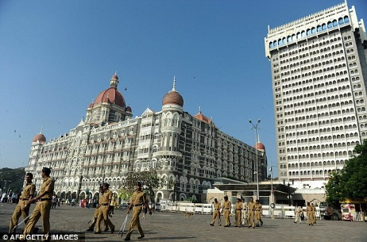

*Success story: India is about to become one of the world's most prosperous nations*

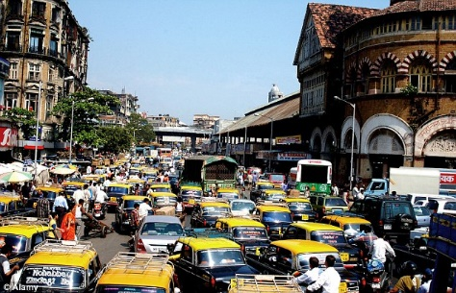

Of equal importance was the opening of minds to new ideas, the erosion of superstition and the introduction of legal systems. A glance today at the list of men and women qualifying for the English Bar will reveal surnames from Asia, Africa and the Far East.

There are also the self-evident imperial success stories: India, about to become one of the richest nations in the world, and the self-governing and prosperous dominions of Canada, Australia, New Zealand and Singapore.

A further and highly significant legacy is found in Burma and other former colonies, where democracy has withered since the colonial authorities left and where political activists justify themselves by invoking traditional British liberties and parliamentary democracy as desirable.

***Principles***

We might very well wonder what the world would have been like without the British Empire. Certainly, if the Dutch or French had developed Australia, it would have been a very different country indeed.

By the end of the 18th century, France was an arthritic, sclerotic society.

If they had gone to Australia in 1788, rather than us, they would simply have imposed a version of the Ancien Regime where what the king said was law. There would have been no sense of parliamentary democracy — the rule of law would have been utterly autocratic.

In Australia, there is still a great residue of loyalty and affection for Britain. This is evident in many of the countries that made up the British Empire.

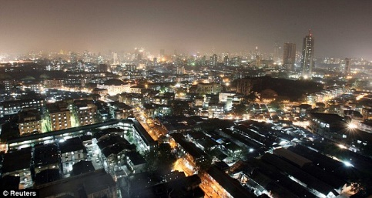

*Legacy: Once under British rule, Mumbai is now a global commercial centre*

Twenty years ago, at a bar in Delhi, the bartender leaned across and told me: ‘You gave us a leg up and knew when to leave the party.’

Of course, such a vast enterprise played host to human failings; its rulers made misjudgments, sometimes failed to understand their subjects and, at times, behaved badly.

But it is worth remembering that when they did so, their actions were publicly condemned and, in some instances, punished. That was thanks to the rule of law and the principles of justice upon which the Empire was built.

Regardless of this week’s revelations, we should be proud of Britain’s profound influence on so many of the peoples of the world — and we should certainly never apologise for it.